Design & Graphics Customization Document
Notes
A | Sender Name and Email Address:  Magic Mirror <sales@magicmirror.me>
B | Email Subject:  Hello from Magic Mirror
C | Logo  * Logo should be in PNG format with invisible background.
D | Email Title:  Hello from Magic Mirror
E | Email Text:  Just had my photo taken by the Magic Mirror, what do you think?
F | Share to Twitter  Just had my photo taken by the Magic Mirror, what do you think?
G | Follow Link - Facebook  Input your Facebook link here (if any)
Follow Link – Twitter
Input your Twitter link here (if any)

Follow Link – YouTube
Input your YouTube link here (if any)

Follow Link – Linked In
Input your Linked In link here (if any)

Follow Link – Instagram
Input your Instagram link here (if any)

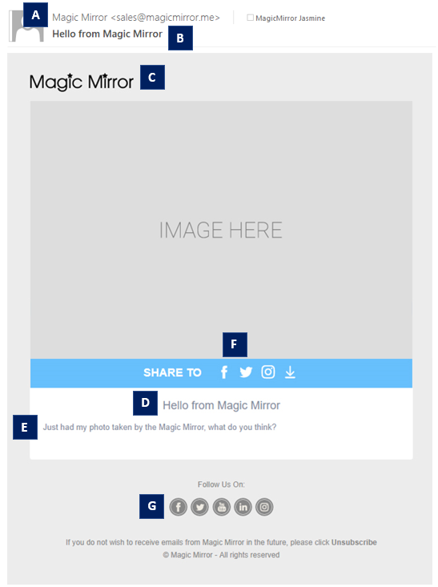
Email Sharing

Notes
A | Disclaimer 1  - Disclaimer Text:  Input your disclaimer texts here (if any)  - Opt-in Rule (select one only):  - Compulsory  - Optional
B | Disclaimer 2  - Disclaimer Text:  Input your disclaimer texts here (if any)  - Opt-in Rule (select one only):  - Compulsory  - Optional
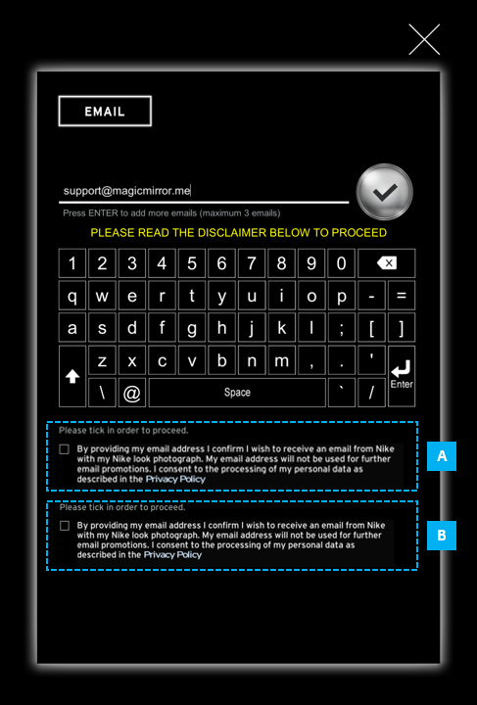
Disclaimers
* URL can be included as part of the disclaimer texts where user will be directed to the destination page when the URL is clicked.

